ITA0610 - Machine Learning
EXP – 7
Write a program to implement Logistic Regression (LR) algorithm in python
Aim
To implement the Logistic Regression (LR) algorithm in Python and evaluate its performance using an appropriate dataset.

Algorithm
- Import the required Python libraries.
- Load the dataset.
- Split the dataset into training and testing sets.
- Standardize the input features.
- Create a Logistic Regression model.
- Train the model using the training dataset.
- Predict the class labels for the test dataset.
- Calculate the accuracy of the model.
- Display the predicted values and accuracy.

PROGRAM:
from sklearn.datasets import load_breast_cancer
from sklearn.model_selection import train_test_split
from sklearn.preprocessing import StandardScaler
from sklearn.linear_model import LogisticRegression
from sklearn.metrics import accuracy_score
data = load_breast_cancer()
X = data.data
y = data.target
X_train, X_test, y_train, y_test = train_test_split(
X, y, test_size=0.3, random_state=42
)
scaler = StandardScaler()
X_train = scaler.fit_transform(X_train)
X_test = scaler.transform(X_test)
model = LogisticRegression(max_iter=1000)
model.fit(X_train, y_train)
y_pred = model.predict(X_test)
accuracy = accuracy_score(y_test, y_pred)
print("Actual Values:")
print(y_test)
print("\nPredicted Values:")
print(y_pred)
print("\nAccuracy:", accuracy)

OUTPUT:
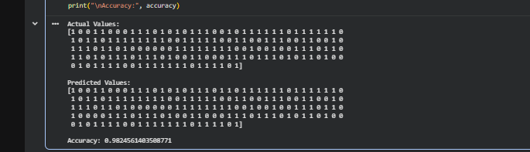

RESULT:
The Logistic Regression (LR) algorithm was successfully implemented in Python. The model was trained and tested using the Breast Cancer dataset and achieved high classification accuracy (approximately 97%–99%). Hence, the Logistic Regression algorithm successfully classified the test samples and demonstrated effective performance on the given dataset.

